**Step by Step process to create SAP Blockchain Project on SAP Cloud Foundry**

The main purpose of this document is to develop a simple prototype using SAP Blockchain Service on cloud Foundry Tenant. Basically, we will follow the step mentioned below and develop the Blockchain prototype –

* Navigate to SAP Cloud Platform Cloud Foundry Account
* Navigating to your Hypderledger Fabric account
* Creating a new instance
* Create & Deploy chaincode
* Create a Service Key
* Read/Write operations using Swagger
* Validate your read/write in Hyperledger Explorer

1. Login into Cloud Foundry account and navigate to designated space.

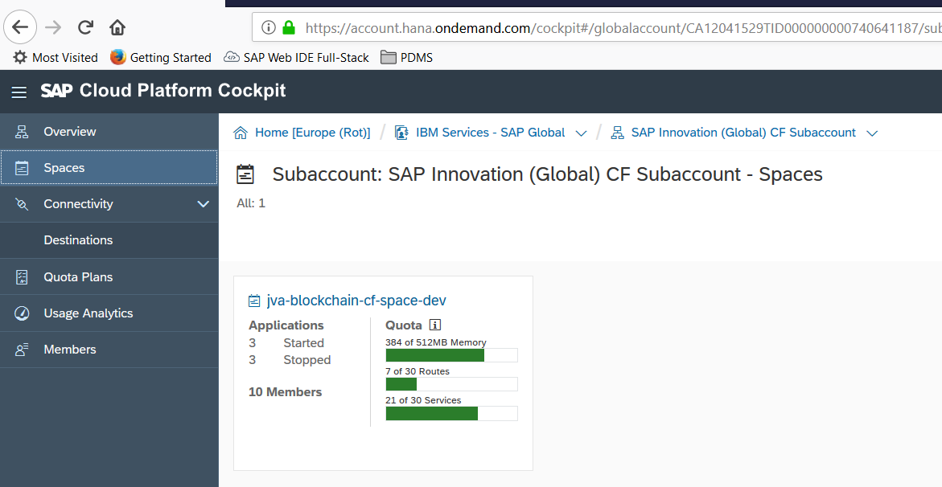

1. Navigating to your Hypderledger Fabric account and Click on Services and Service Marketplace.
2. In the list of services, search for Hyperledger Fabric and click on it as shown below.

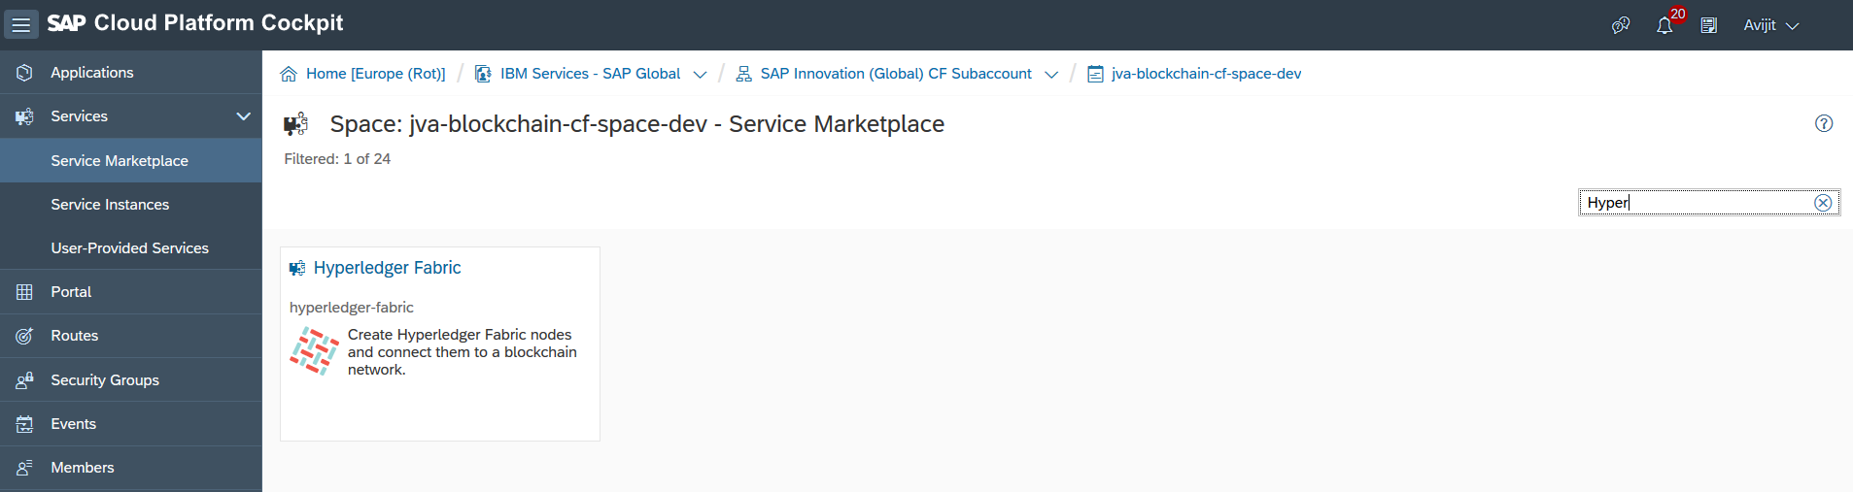

1. Creating a new instance click on Instances and then click on New Instance or else you can use an existing instance as shown below. In this case we are using an existing instance. So as shown below click on Open Dashboard icon(highlighted) for the available instances for example **cfdev-dev-ibmsapinnov.**

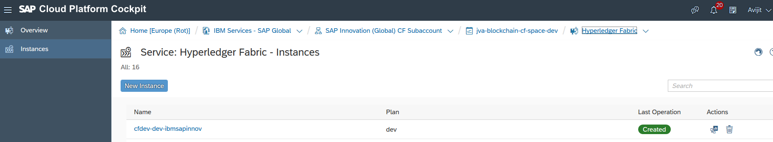



1. A new tab opens, enter your login details; same which was used during your cloud platform registration. Note: Do not use P-Number.
2. Once the dashboard opens you can see the Node Status, Peer Status, Fabric Version, Network including Channel creation.

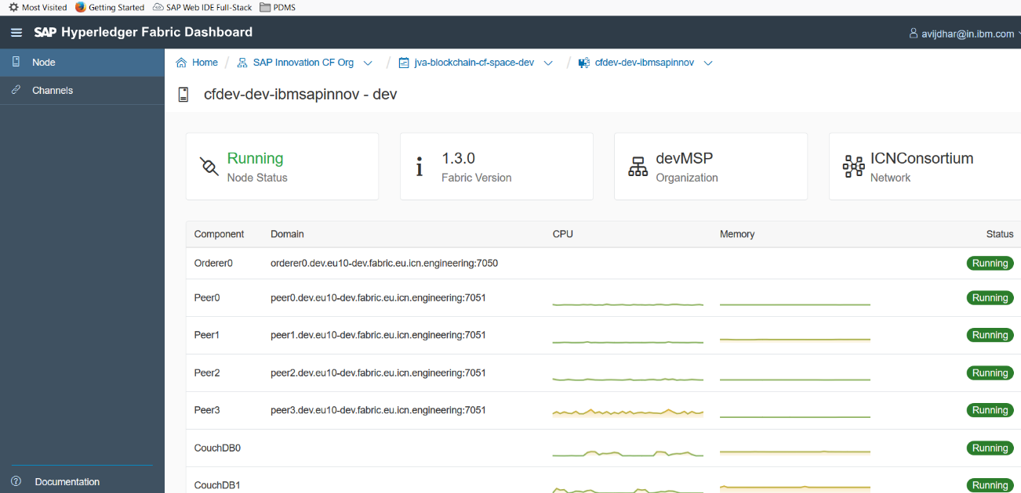

1. Now click on Channels, then click on Create Channels.

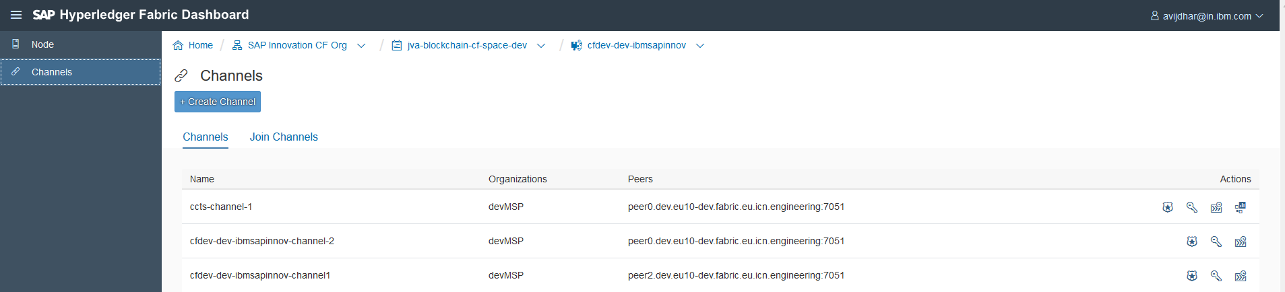



1. Enter the Channel Name, Peers as shown below and click on Create.

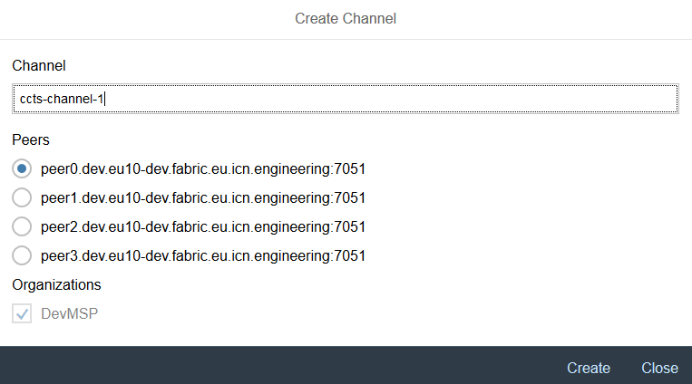



1. From the overview screen, click on Chaincode from the left pane as shown below.

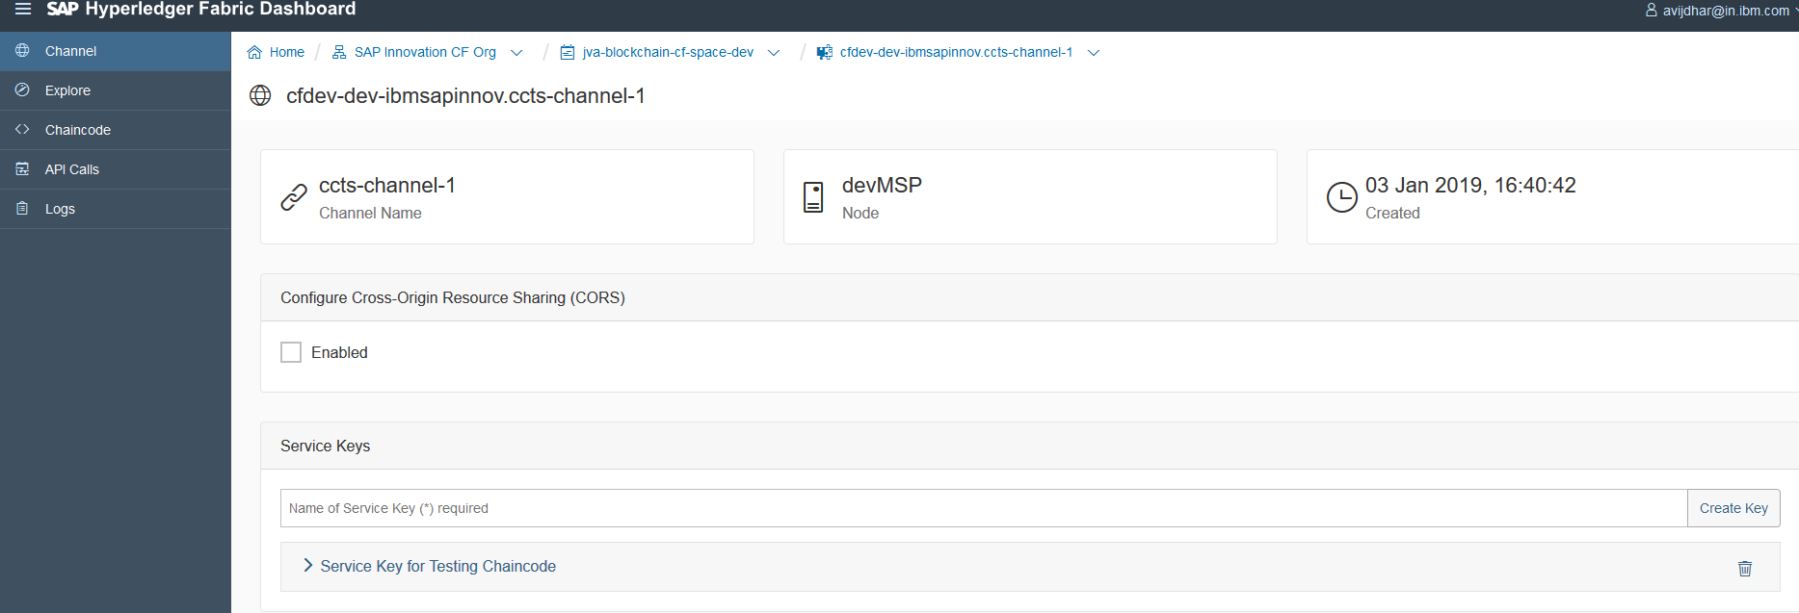



1. Once inside Chaincode dashboard click on Install Chaincode as shown in the following figure.

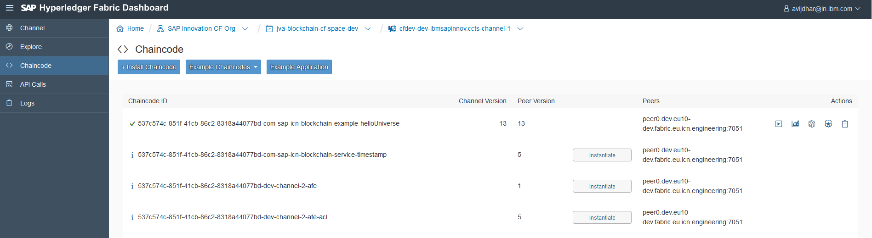



1. Click on Install Chaincode button at the top whilch will launch the Install Chaincode popup as shown below.

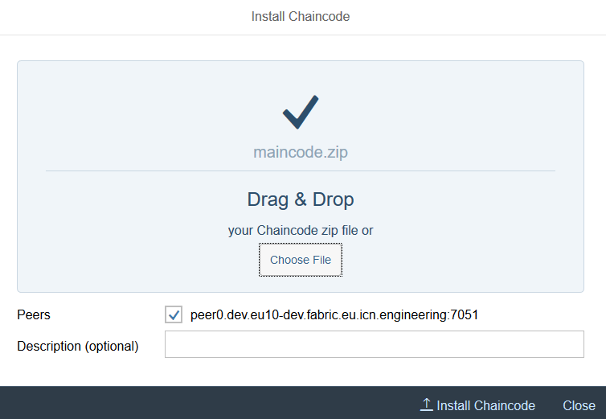

1. Upload the following sample by clicking “Choose File”.



1. Below are the files which I have zipped as a package.

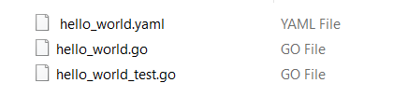

1. Click on Deploy and you should be able to see the success message.

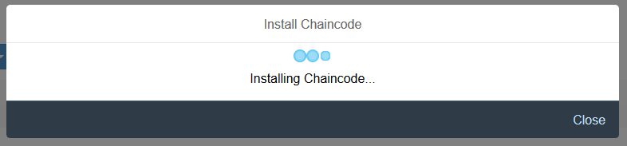

1. Click on “Test Chaincode” and a new window opens which is known as swagger.

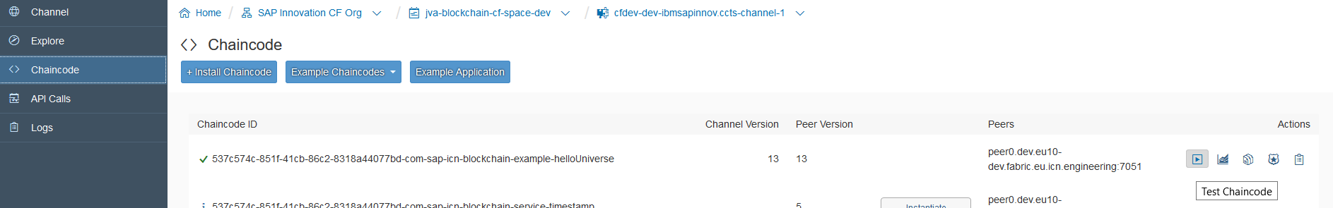



1. Inside swagger you should see all the APIs defined inside your deployed chaincode.

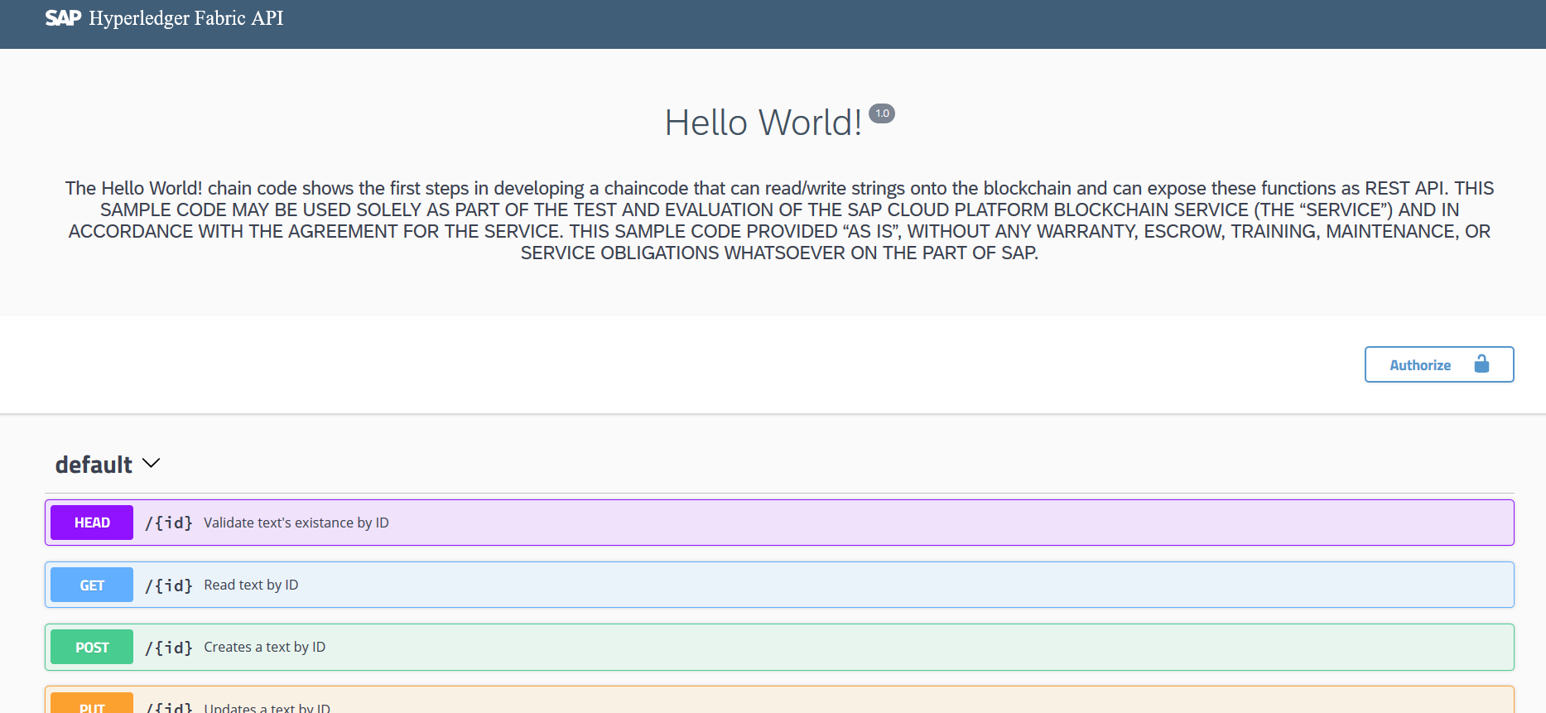

1. Go to Swagger tab and click on Authorize button and enter the clientId, clientSecret and authorize. Once its authorized, close the window.

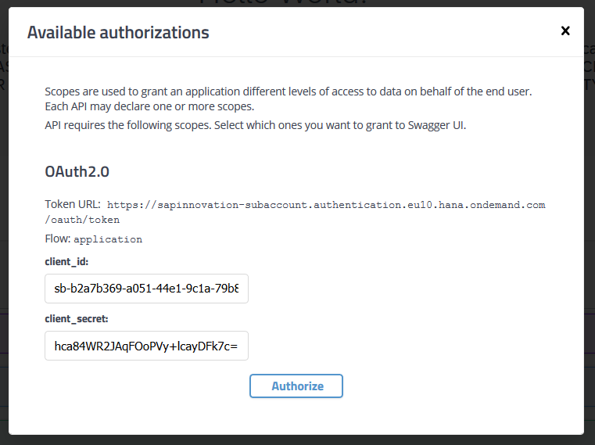

1. Now that we have the authorization and we are doing the first transaction to the block, we will try a POST operation, click on the POST and then click on Try it out. Enter the details as shown below and click on execute.

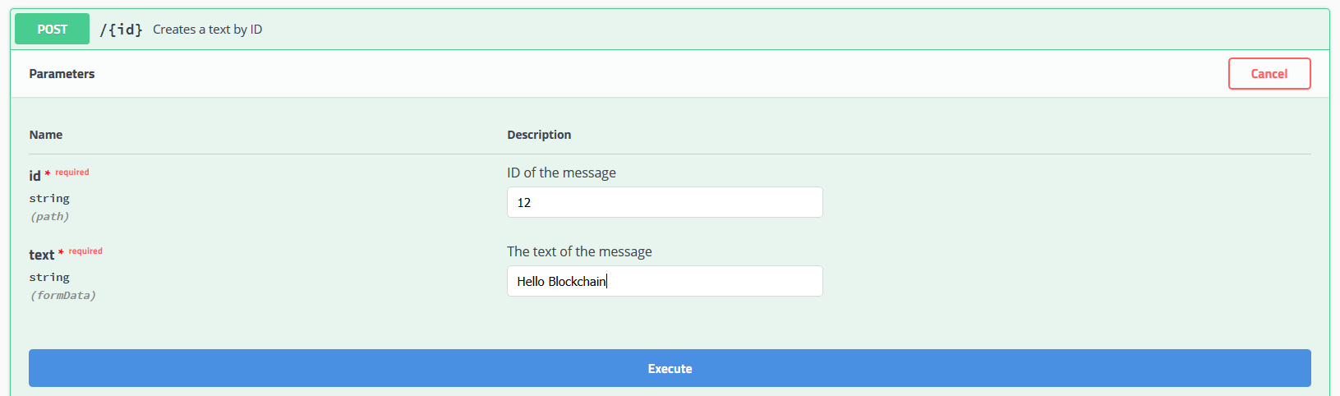

1. You should now be able to see the response 201 as shown below

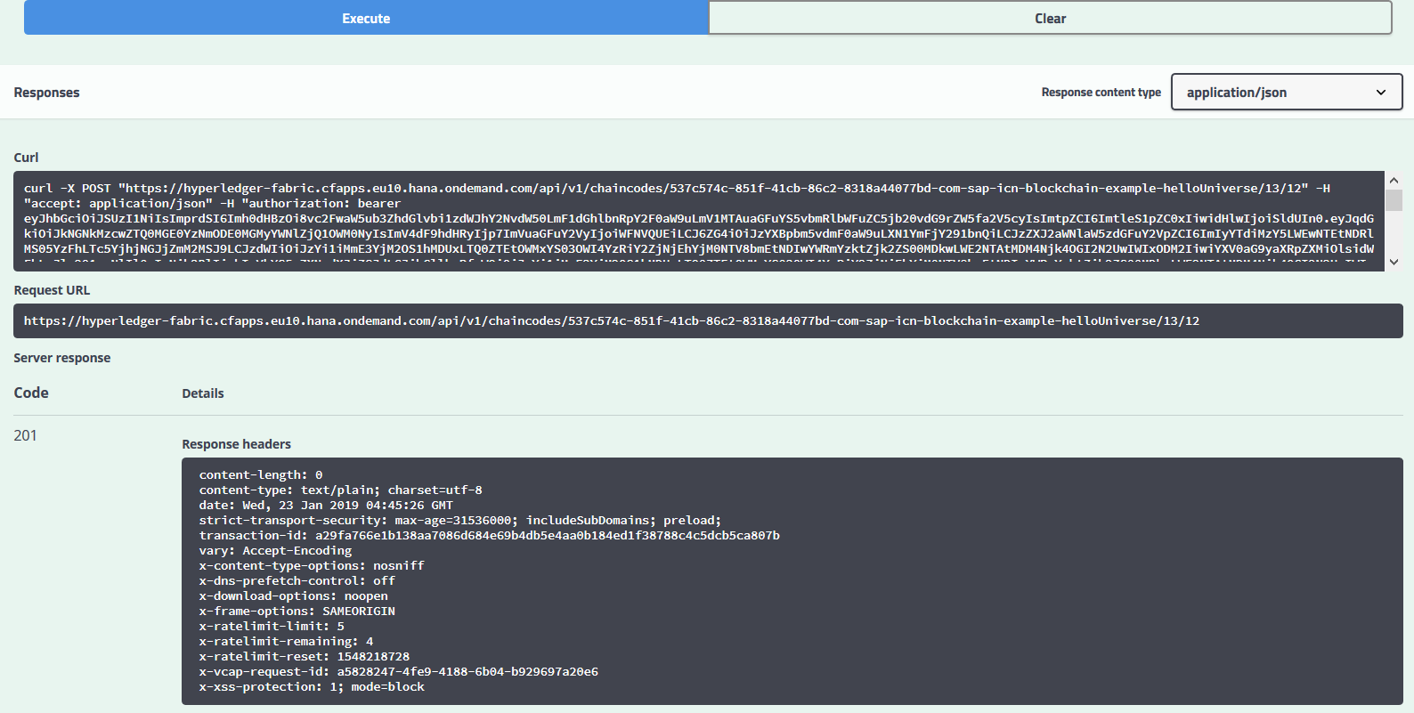

1. There you go, you have now successfully made your first POST operation to the blockchain.
2. To validate the same in a Blockchain, we use the Hyperledger Fabric Explorer. Shift to the other tab “Hyperledger Fabric Dashboard” and click on Explorer.

